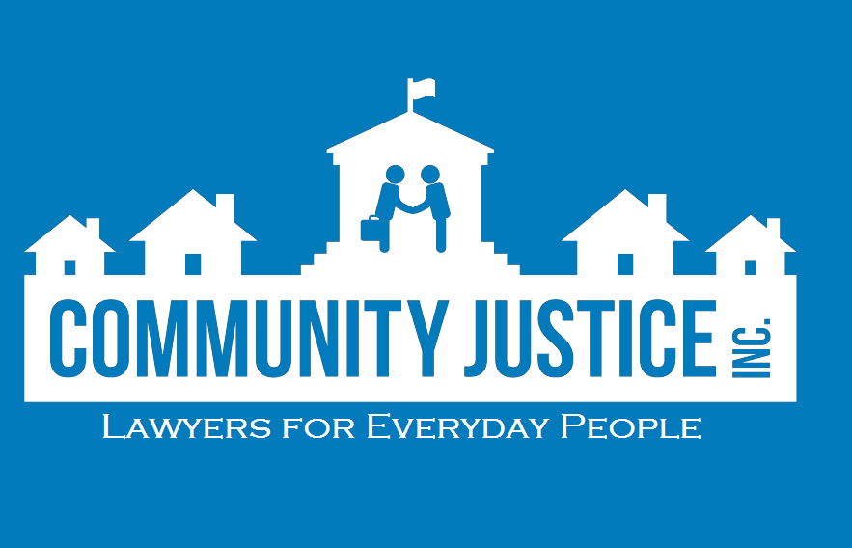
Community Justice Inc. 2019 Fall Fundraiser Donation Form
Thursday, October 17, 5:30-7:30 p.m. at Old Sugar Distillery
CJI is a 501(c)(3) organization dedicated to providing affordable yet exceptional legal services to Wisconsin residents. CJI focuses on holistically supporting clients’ needs at a drastically reduced, sliding-scale rate. Areas of practice include domestic violence, family, landlord/tenant, employment, bankruptcy, and housing law. Without generous contributions from organizations like yours, CJI could not continue to provide high-quality, low cost representation to the families that desperately need it. For your records, CJI’s tax identification number is 20-1228751.

Please return the form by Oct. 4, 2019 to:
Community Justice Inc., 214 N. Hamilton #101, Madison, WI 53703 or contact Jennifer Binkley at 608-442-3003 or JenniferB@communityjusticeinc.org .

Contributed Item(s)
Description of Item(s)
Primary Contact Person |  | Title
Authorized Signature |  | Estimated Value of Contribution $
Name of Company/Firm (for use in Press Releases and Event Materials)
Address |  |  | City/State/Zip
Telephone | Fax |  | Email

Please check one of the following:
My donation is enclosed.
I will deliver my donation to Community Justice, Inc., 214 N. Hamilton St., # 101, Madison , WI 53703 by Oct. 4, 2019
Please call me to make arrangements for clerk from Community Justice, Inc. to pick up my donation.
Pick up arrangements have been made for my donation.
Sponsorship levels:
_____Gold: $1000 sponsorship; name/logo listed on event signage as $1000 sponsor; name/logo listed on Web site for one year with link; inclusion in event press releases and materials; introduction at event and opportunity to address the group.
_____Silver: $500 sponsorship; name/logo listed on event materials as $500 sponsor; name listed on Web site for one year with link; verbal recognition at event; inclusion in event press releases and materials.
_____Bronze: $250 sponsorship; name listed on event materials as $250 sponsor; name listed on Web site for one year with link; verbal recognition at event.
Thank you in advance for your time and consideration!

